Supplementary Material

*1A. Murray Booth, 2,3Ben Murphy, 2Ilona Riipinen, 1Carl J. Percival, 1David O. Topping,*

*1School of Earth, Atmospheric and Environmental Science, University of Manchester, Manchester, U.K.*

*2Department of Applied Environmental Science and Bolin Centre for Climate research, Stockholm University, Stockholm, Sweden*

*3Department of Meteorology and Bolin Centre for Climate research, Stockholm University, Stockholm, Sweden*

**A. Experimental Method**

Samples were prepared by taking an equimolar mix of the C3-C10 and C12 straight chain dicarboxylic acids (sourced from Sigma Aldrich with purities of 99% or higher) and heating the mixture until the highest melting point diacid (C12) had dissolved into the resultant liquid. Subsequent reheating of the sample illustrated a homogenous solid solution where all components simultaneously became liquid at 80 C, a lower melting point that any of the individual acids. Subsequent heating and cooling had no further effect on the mixture as confirmed by repeated DSC measurements. For measurements at different water mole fractions, water was measured out volumetricly using a syringe and was mixed in with the diacids using the same heat-cool cycle in a sealed container.

1. Diffusion

To test the Stokes-Einstein equation, the infinite dilution diffusion coefficient for water was measured in different viscosity media using Taylor Dispersion. Measurements we made using an Agilent 1260 HPLC system with an Isocratic pump, refractive index detector (RI), and 20 μl manual injection port controlled using Chemstation software. The injection valve was connected to the detector via a 10 m long 0.25mm diameter PEEK tube which was immersed in a water bath. Solvent degassing was carried out offline by pumping the headspace of the solvent bottle. The solutions were made from 0.05 g of solute dissolved in 10 ml of solvent. The flow rate was 0.17ml min-1 which corresponded to a rentention time of 30 min. The diffusion coefficient *D* is given by:

$D=\frac{0.231r^{2}t_{r}}{{\left(W_{1/2}\right)}^{2}}$ (1)

where *tr* is the retention time, *r* the tube internal diameter and *W1/2* is the full width half maximum of the Gaussian peak of the solute at the RI detector (1). The theoretical requirements of a Taylor dispersion requirements are described by the following inequalities (2).

$\frac{{\overline{u}}_{0}r}{D}>700$ (2)

where *ū0* is the mean velocity of the fluid. For our experiments *D* ranges from 7×10-11 to 5×10-9 m2s-1.

(3)

In order to ensure laminar flow in the system, the Reynolds number *Re* should satisfy

$Re=\frac{2{\overline{u}}_{0}rρ}{η}$ (4)

where ρ is the density of the fluid and η is the viscosity. Secondary flows in the tubing coil can be negelected if ω the ratio of the coil radius to the internal radius is >100. It is 472 in our case. Additionally the Dean *De* and Schmidt *Sc* numbers should satisfy:

${De}^{2}Sc≤20$ (5)

where *De=Reω-1/2* and *Sc=η/(ρD)*.

Table S1 shows the different flow parameters during the experiments. Dtr/r2 >10 is violated for acetone and methanol, Loh et al., 1993 suggest a error of ±2% from this condition not being met for similar flow conditions. De2Sc <20 is violated for almost all the runs, errors from this effect are around ± <0.1% so violations of this condition are dwarfed by other sources of error. Oleic acid was sufficiently viscous that the flow rate was lower than for the other solvents.

Figure S1 shows infinite dilution binary diffusion coefficients for water measured in different viscosity media (Oleic acid, ethylene glycol, propanol and acetone) using Taylor dispersion. Also shown are estimates of the diffusion coefficient. This was done by first calculating the hydrodynamic radius of water using a measured self diffusion coefficient (3), then applying this to experimental values of the different media viscosities, assuming the Stokes-Einstein relation. Over the range of viscosities measured here (0.027 Pa s for oleic acid to 0.0004 Pa s for acetone) the Stokes-Einstein equation predicts diffusion coefficients to within less than ±50% of the measured value with no systematic bias. This suggests the Stokes-Einstein equation is a valid way to related diffusion and viscosity, although the relationship is known to break down for high viscosity values.

1. Viscosity

Viscosity measurements we made using a TA Instruments DH-1 rheometer operating in oscillation mode. The system consists of an upper and lower plate, the upper plate is mechanically controlled to monitor displacement, lateral force and torque (see Figure S2). The lower plate has a peltier element for precise temperature control. The upper plate is lowered onto the sample, the sample is then heated to a liquid (80-90 C) to ensure there are no gaps and the entire plate area is covered, the distance between the plates is 1500 µm.

Oscillation mode consists of the upper plate being moved sinusoidally back and forth over a very narrow displacement. Sinusoidally oscillating shear strain (γ) produces a stress (τ) phase shifted by an angle (δ) (See Figure 2). The stress wave can be broken into two waves, in phase and out of phase (90) with respect to the strain wave.

$τ=τ´+τ´´={τ´}_{0}sinωt+{τ´´}_{0}cosωt$ (6)

The in phase or elastic modulus G’ and the out of phase, viscous or loss modulus G’’ come from

$G^{'}=\frac{{τ'}_{0}}{γ_{0}}$ (7)

And

$G^{''}=\frac{{τ^{''}}_{0}}{γ_{0}}$ (8)

the dynamic viscosity can then be calculated from

$η=\frac{G''}{ω}$ (9)

where ω is the angular frequency of the plate.

For our oscillation experiments we chose a small displacement of 1e-4 radians based on experience with polymer melt samples and an oscillation frequency of 1 Hz. Heating and cooling temperature ramps were from -5 to 90 C to cover from the region around room temperature and up to the point where the sample became liquid. The temperature rate was 5C/min to match DSC rates and is typically of maximum possible cooling rates an aerosol particle might experience during rapid convection. The coefficient of expansion of the steel parallel plates was measured over the range of temperatures to allow us to compensate for the thermal expansion of the metal plates. To account for volume changes in the sample, the distance between the plates was constantly adjusted to maintain a constant lateral (perpendicular to plate) force of 4N.

1. XRD

Powder x-ray diffraction (XRD) was carried out on a Pan Analytic X’PERT diffractometer using Cu K-α scanning from 5˚ to 75˚ in 2θ angle. The extremely broad peaks/uneven baseline are indicative of amorphous material. The single peak present is from the sample holder so there is no crystalline phase present (Figure S3).

1. IR

Fourier transform infra-red spectroscopy (FTIR) was performed on a Bruker ALPHA spectrometer. Spectra are normalised to the peak at 1690 cm-1. The diacid mix shows no IR peaks (Figure S4) that are not present in the synthesised spectra from the individual acids indicating there was no chemical change during sample preparation.

1. DSC

DSC performed on a TA Instruments Q200 with 30 ml min-1 flow of N2 purge gas and cooling/heating rates of 5 deg min-1. It was operated in modulated mode (MDSC) in order to monitor Heat capacity in addition to heat flow. Repeated cycles show no change indicating the sample was thermally stable over the course of our measurements. There is a large melting transition between 60-40°C which matches what is seen in the rheometer. There is another transition around 10-20°C which has no matching transitions in the rheology (Figure S5). We suspect this to be due to the roational freedom of the molecules getting more restricted.

**B. Calculation and analysis of mixing and evaporation timescales**

1. Mixing timescale

We calculate the timescale of particulate-phase mixing (conceptualized as uptake from a surface layer to the bulk) with the following equation:

$τ_{mix}= \frac{r_{p}^{2}}{4π^{2}D_{mix}}$ (10)

where rp is particle radius and Dmix is the particle-phase diffusivity derived from the experimentally determined viscosity (4). In order to calculate the diffusivity via the Stokes-Einstein relationship (eq. 1), we assume a hydrodynamic radius, r, is 1 nm.

1. Evaporation timescale

For the evaporation timescale, we first need to calculate the evaporation rate, which we represent with the kinetic-regime mass transfer equation modified by the transition-regime correction term as was used in Riipinen (5):

$I= \frac{4πβr_{p}D_{air}p_{eq}}{kT}$ (11)

where I is the mass transfer rate (molecules s-1­­), β is the dimensionless transition-regime correction term, Dair is the diffusivity of the condensing species in air, peq is the vapour pressure of the condensing species corrected for temperature and surface effects, k is the Boltzmann constant and T is temperature (K) of the system. The transition-regime correction, β, is calculated with the formula of Fuchs and Sutugin (6):

$β= \frac{1+Kn}{1+\left(\frac{4}{3α}+0.377\right)Kn+\frac{4}{3α}{Kn}^{2}}$ (12)

with Kn the Knudsen number and α the accommodation coefficient. The evaporation timescale is then the reciprocal of the evaporation rate:

$τ_{evap}= \frac{kT}{4πβr_{p}D_{air}p_{eq}}$ (13)

For these calculations, several compounds properties must be assumed (we emphasize this exercise is meant as an order-of-magnitude estimate of the relative importance of mixing processes). We fix compound molecular weight at 100 g mol-1, Dair is 5.0e-6 m­2 s-1, accommodation coefficient is 1, surface tension is 0.05 N m­-1, and enthalpy of vaporization is 100 kJ mol-1. The equilibrium vapour pressure is calculated with these parameters knowing the effective saturation concentration (C*).

$p_{vap}= C^{*}RTM_{w}$ (14)

$p_{sat}= p_{vap}e^{\left(\frac{∆H}{R}\left(\frac{1}{T}-\frac{1}{T_{0}}\right)\right)}$ (15)

$p_{eq}= p_{sat}e^{\frac{2.0M_{w}σ}{RTρr_{p}}}$ (16)

Equation 14 is the Ideal Gas Law, 15 is a common form for the Clausius-Clapeyron Equation and 16 quantifies the Kelvin effect relevant for small particles with significant curvature. An important point is that C* represents the saturation concentration of the species above a generalized solution. In other words it is the product of the pure component saturation concentration, the activity coefficient (a function of the mixture composition), and the mole fraction of the species in the mixture.

1. Definition of dimensionless parameter (Χ)

Several properties govern the relative importance of mixing and condensation/evaporation processes. Particle size, temperature, and mixture composition, all play a role according to the model described above. In order to quantitatively compare the mixing and evaporation timescales, we define a dimensionless parameter Χ:

$X= \frac{τ_{evap}}{τ_{mix}}$ = $\frac{kTπ}{D_{air}}*\frac{1}{βr_{p}^{3}}*\frac{D_{mix}}{p_{eq}}$ (17)

As is evident from this definition, when X << 1 the timescale of mixing is much greater than that of evaporation. A model seeking to faithfully represent gas/particle dynamics should, in that case, explicitly treat mixing in the particulate phase. On the other hand, when X >> 1, the timescale of evaporation is very large relative to that of mixing and mixing processes can be largely ignored. Figure S6 shows calculations of X as a function of particle-phase diffusivity and particle size for three different saturation concentrations. The linear relationship between peq and X as well as Dmix and X is evident. For species with C* = 10-3 µg m-3, particle-phase diffusivities lower than ~10-10 cm2 s-1 result in low values of X for accumulation mode sized particles. For species at 1000 µg m-3, evaporation timescales are quite short so most of the plotted diffusivity-particle size space reflects quite low X values, reflective of strong dependence on particle-phase mixing.

**C. Pure component and multi-component viscosity predictive techniques.**

The method of Nannoolal (7) was used to first predict the value of sub cooled liquid viscosity for each component in the mixture. The method uses the same fragmentation pattern of the pure component vapour pressure method similarly by Nannoolal (8). The group-contribution method GC-UNIMOD (9) was first combined with predictions of pure component (liquid state) viscosity of Nannoolal (7). Interaction parameters in GC-UNIMOD were fit to VLE data, thus developing a model similar in nature to the UNIFAC concept. In addition, the predictions from the method of Nannoolal (7) were used in the mixing rule presented by Bosse (10). This method follows the concept of relating the viscosity of the mixture to the excess Gibbs energy of that mixture, for which we used the activity coefficient model of AIOMFAC (11).

**References**

1. Alizadeh A, Nieto de Castro CA, Wakeham WA. (1980) The theory of the Taylor dispersion technique for liquid diffusivity measurements. *Int J Thermophys.* (1) 243.
2. Loh W, Tonegutti, CA, Volpe PLO (1993) Diffusion coefficients of aqueous phenols determined by the Taylor dispersion technique. Evidence for solute adsorption on the walls of Teflon tubing. *J Chem Soc Faraday Trans* (89) 113-118.
3. Holz M, Heil SR, Sacco A (2000) Temperature-dependent self-diffusion coefficients of water and six selected molecular liquids for calibration in accurate 1H NMR PFG measurements. *PCCP* (2) 4740-4742.
4. Shiraiwa M, Ammann M, Koop T, Pöschl U. Gas uptake and chemical aging of semisolid organic aerosol particles (2011) *PNAS.* (108) 11003-11008.
5. Riipinen I, Pierce JR, Donahue NM, Pandis, SN (2010) Modeling the evaporation of organics inside thermodenuders: Kinetics vs. thermodynamics. *Atmos. Environ.* (44) 597-607.
6. Fuchs NA and Sutugin AG (1970): Highly Dispersed Aerosols, Ann Arbor Science Publishers.
7. Nannoolal Y., Rarey J., Ramjugernath D. (2009). Estimation of pure component properties. Part 4: Estimation of the saturated liquid viscosity of non-electrolyte organic compounds via group contributions and group interactions. Fluid Phase Equilib, 281 (2), 97-119 (2009)
8. Nannoolal Y., Rarey J., Ramjugernath D.(2008). Estimation of pure component properties: Part 3. Estimation of the vapor pressure of non-electrolyte organic compounds via group contributions and group interactions. Fluid Phase Equilib, 269(1-2), 117-133.
9. Cao, W.; Knudsen, K.; Fredenslund, Aa.; Rasmussen, P. Group-Contribution Viscosity Predictions of Liquid Mixtures Using UNI-FAC-VLE Parameters.Ind. Eng. Chem. Res.1993,32, 2088-2042.
10. Bosse D, (2005) *Diffusion, Viscosity, and Thermodynamics in Liquid Systems* PhD thesis, Technical University of Kaiserslautern.
11. Zuend, A., Marcolli, C., Luo, B. P., and Peter, T.: A thermodynamic model of mixed organic-inorganic aerosols to predict activity coefficients, Atmos. Chem. Phys., 8, 4559-4593, doi:10.5194/acp-8-4559-2008, 2008.

Table S1 Flow parameters for Taylor Dispersion

|  |  |  |  |  |  |
| --- | --- | --- | --- | --- | --- |
|  | >10 | >700 | <2000 | >100 | <20 |
|  | Dtr/r2 | ū0r/D | 2 ū 0rρ/η | ω | De2Sc |
| acetone | 53.71848 | 552.1153 | 12.81802 | 472.4409 | 29.95941 |
| methanol | 24.31414 | 1219.816 | 65.54873 | 472.4409 | 338.4864 |
| propanol | 7.136307 | 4156.042 | 2.081793 | 472.4409 | 36.62688 |
| ethylene glycol | 2.107526 | 14072.8 | 0.344821 | 472.4409 | 20.54266 |
| oleic | 23.58929 | 1257.299 | 0.005486 | 472.4409 | 0.029197 |

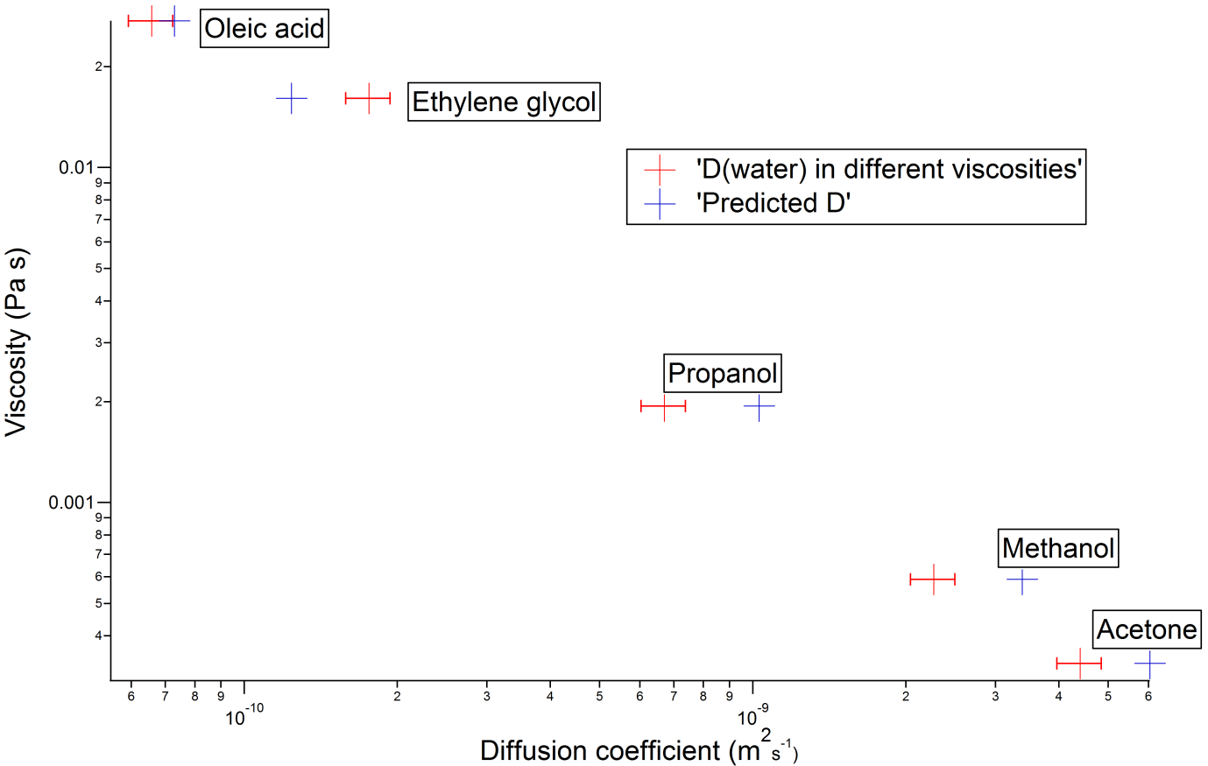

Figure S1 Infinite dilution binary diffusion coefficients of water in different media with varying viscosities, assuming the Stokes-Einstein relation between the viscosity of the mixture and water diffusion coefficient.

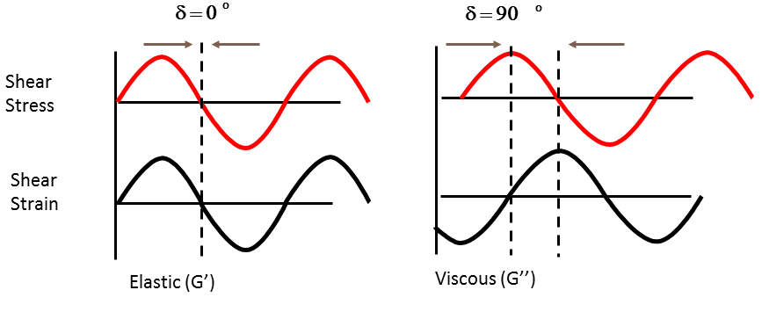

Figure S2 In phase and out of phase shear strain response to a shear stress.

Figure S3 Powder XRD of diacid mix.

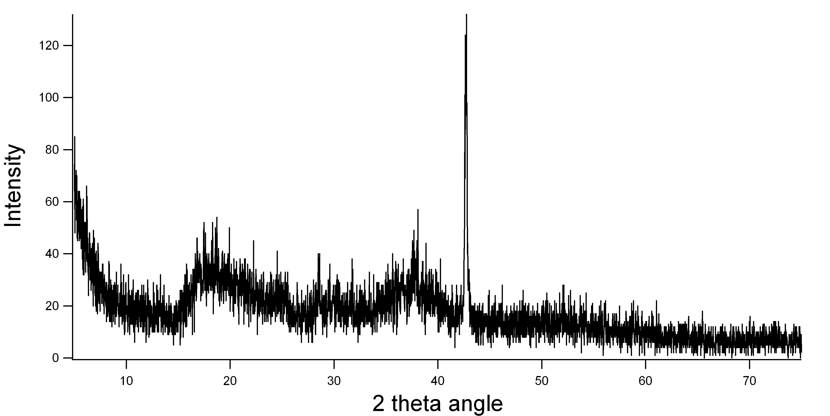

Figure S4 FTIR spectra of diacid mix.

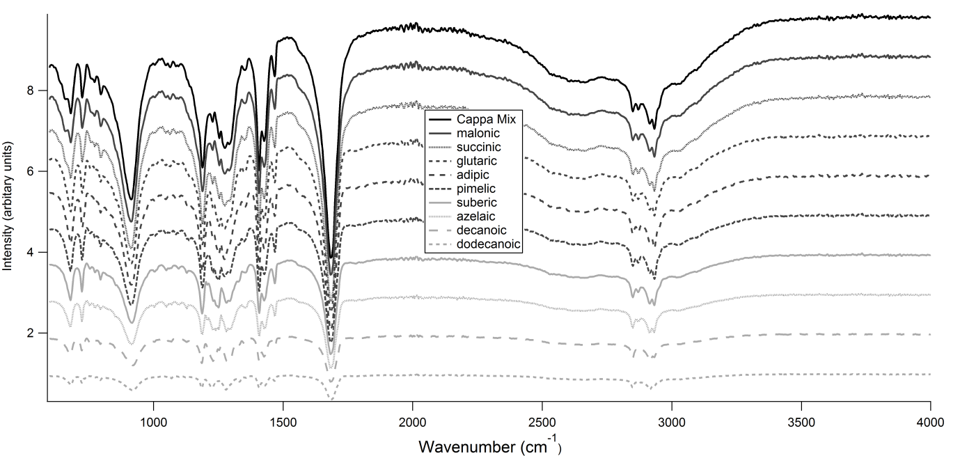

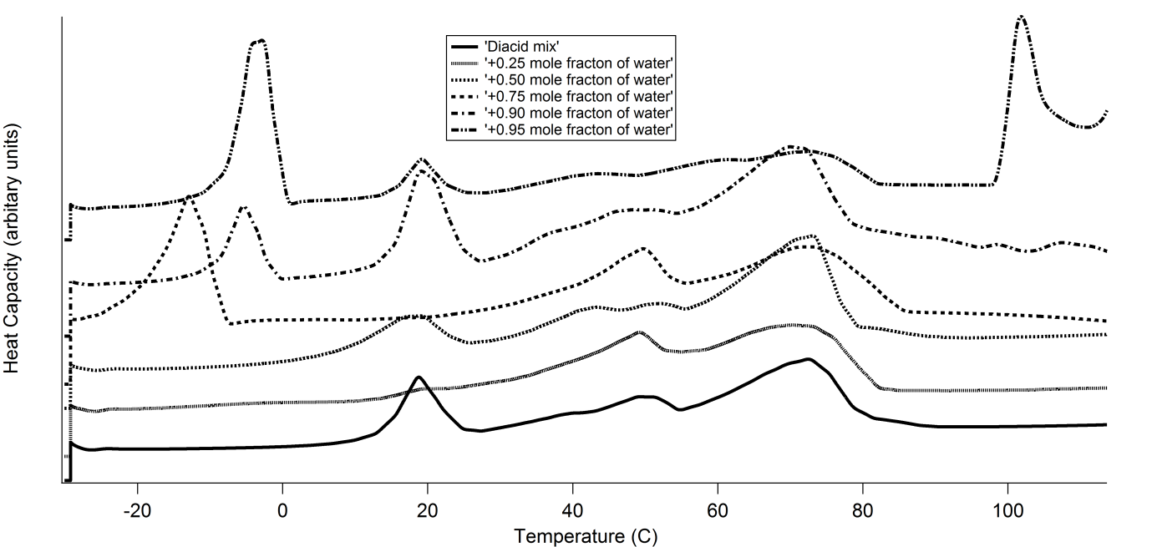

Figure S5 DSC thermograms of the diacid mix.

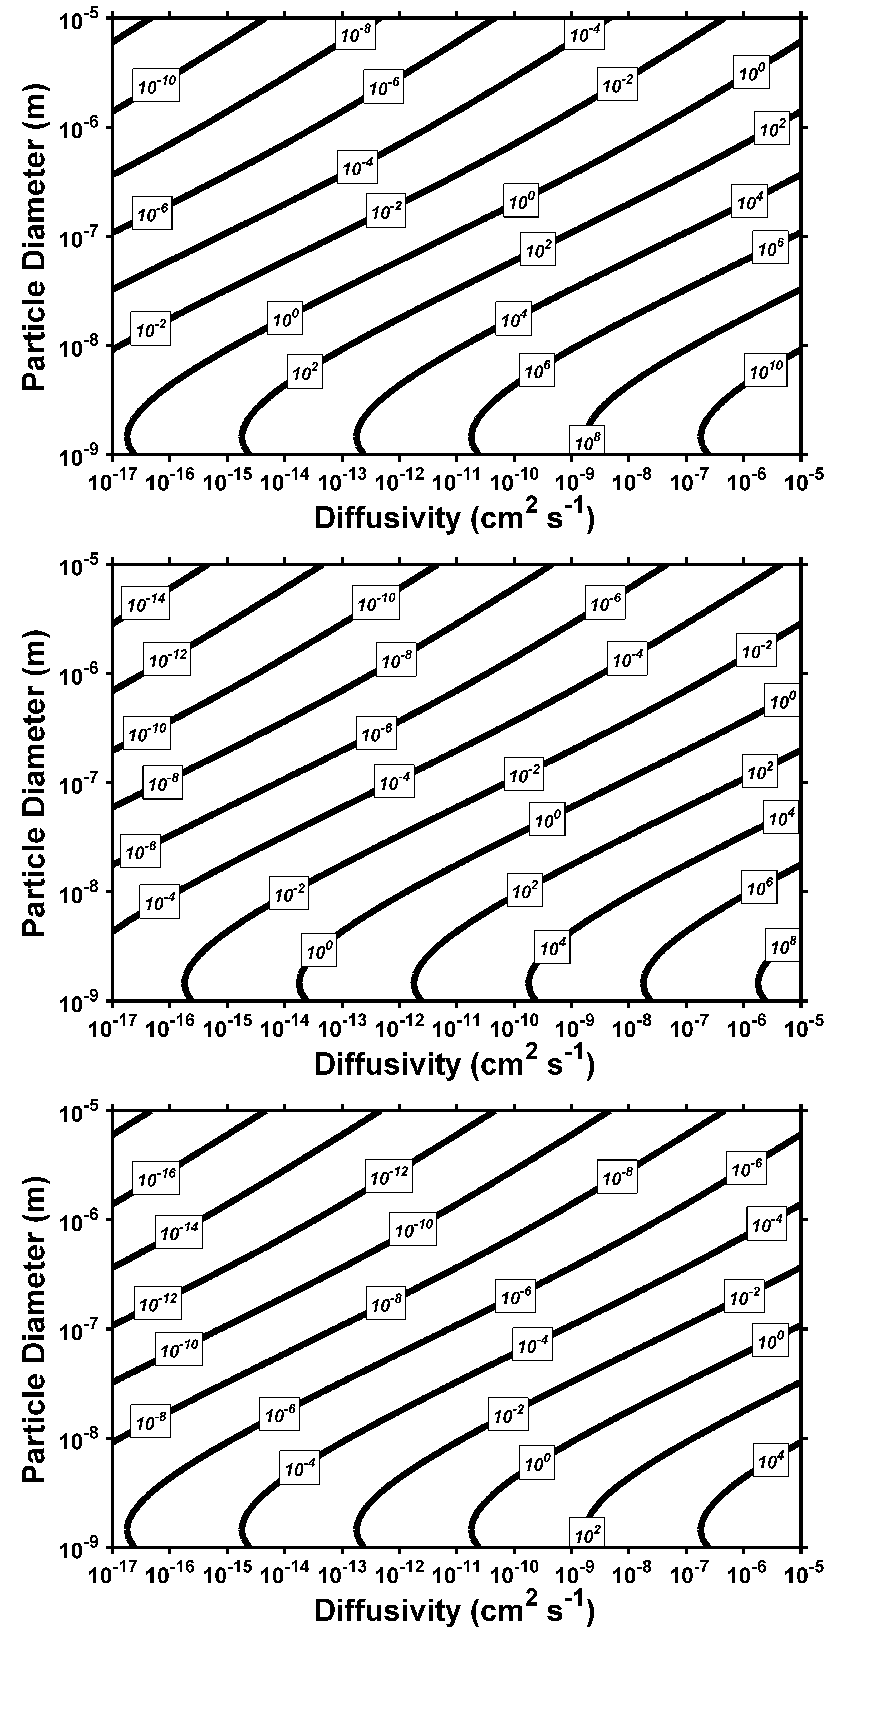

1. C* = 1 µg m-3
2. C* = 10-3 µg m-3
3. C* = 1000 µg m-3

**Figure S6.** The dimensionless parameter X as a function of particle-phase diffusivity and particle diameter for species with an effective saturation concentration equal to a) 10-3 b) 1 and c) 1000 µg m-3.